# EE654 Simulation Assignment #1 – Buck Converter

1.

## VL at last 10 cycles

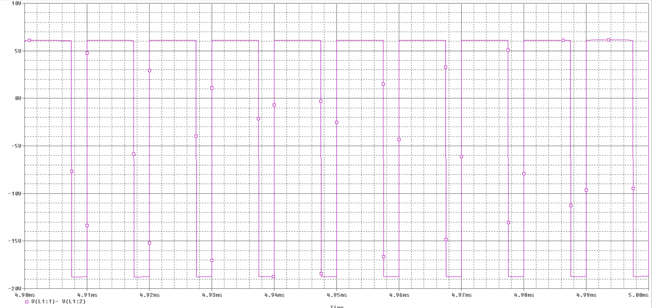

## Vo at last 10 cycles

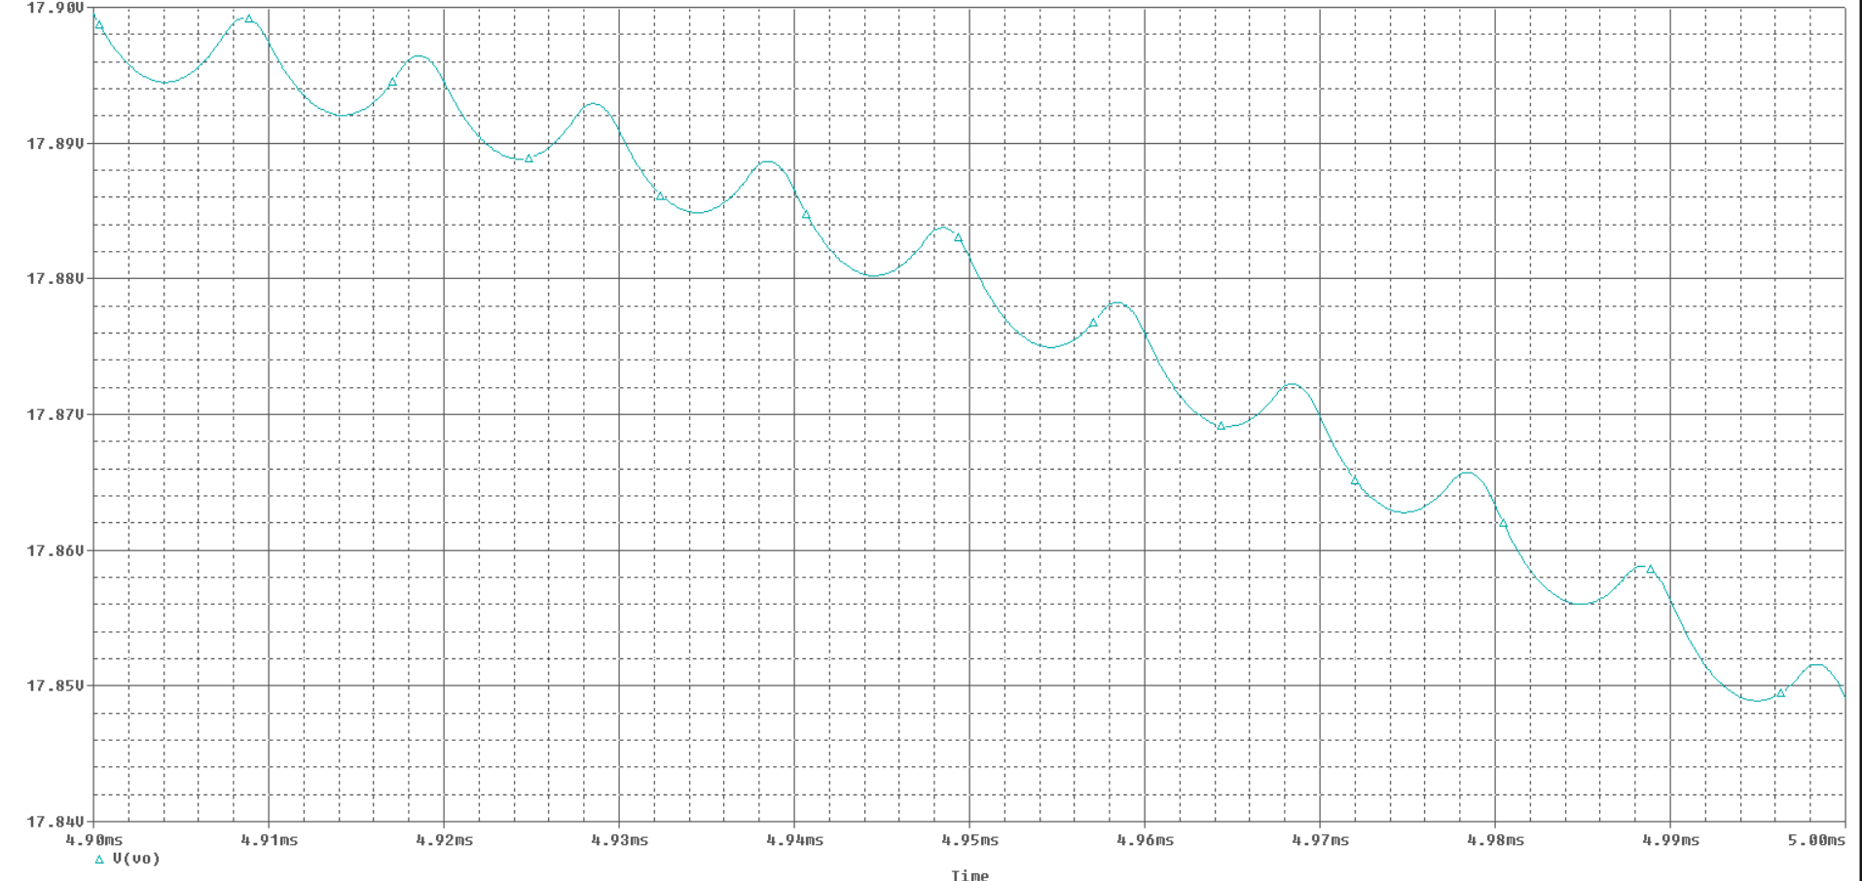

## IL at last 10 cycles

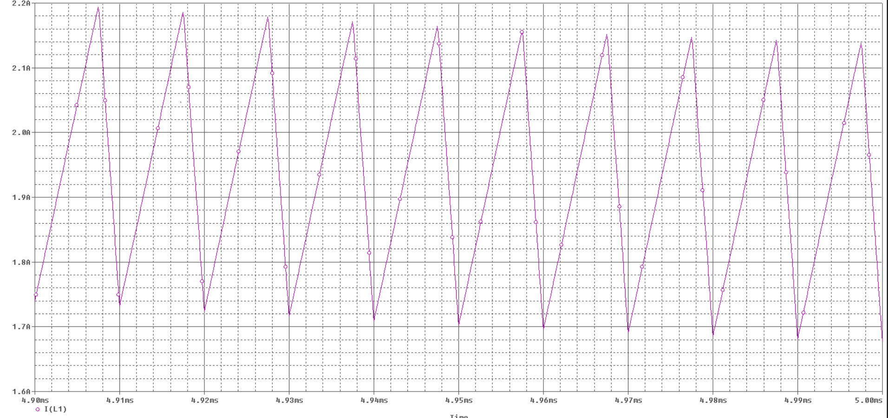

2.

## Average value of Vl



3.

## IL



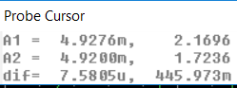

Measured peak-to-peak value = 446.973 m

Calculated peak-to-peak value by →

4)

## IC



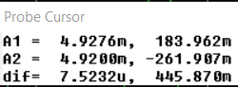

iC follows the same waveshape as the ripple in iL, and has almost an identical peak to peak current. Average value is approximately 0.

5)

## Iin



Average value of Iin = 1.48A

Theoretical value computed by →

6)

New value for inductor gives the following ∆iL

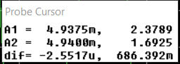

Which is similar to the one which was required

7)

Output power is halved by changing R from 9 Ω to 18 Ω.

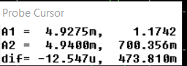

In spite of the fact that the load has been halved, the peak-to-peak value of the inductor current remains approximately the same. This is because the peak-to-peak current isn’t affected by the changing load (see equation EQ 3-16, it’s only dependent on Vin, Vo, D, L, and Ts)

8)



As the graph shows, the converter is operating in the critical condition mode (since IL goes to 0 at the end of each cycle)

# Buck-boost-converter

1)

## IL



## VL



## Vo



2)

## Average value of VL



3)

## Il



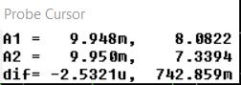

Measured peak-to-peak value = 742.859 mA

Calculated peak-to-peak value by →

4)

## IC/IDiode



The capacitor current follows the ripple in the diode by an offset of -2A (the output current). The average value of the capacitor current (shown by the blue line) is approximately 0.

5)



The average value of Iin is shown in the red line. It is about 5.79A.

Theoretical value computed by →

6)

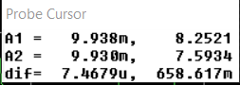

Measured value for ∆il is 658.6 mA which is similar that the one which was required.

7)

Output power is halved by changing R from 15 Ω to 30 Ω.

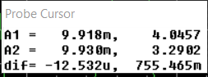

In spite of the fact that the load has been halved, the peak-to-peak value of the inductor current remains approximately the same. This is because the peak-to-peak current isn’t affected by the changing load (see equation EQ 3-28, it’s only dependent on Vin, D, L, and Ts)

8)



As the graph shows, the converter is operating in the critical condition mode (since IL goes to 0 at the end of each cycle)